**HORMISDALLEN SCHOOL - KYEBANDO**

**PRE- PLE SET 9 EXAMINATIONS, 2023**

**PRIMARY SEVEN SCIENCE**

**Duration: 2 Hours 15 Minutes**

**NAME: ______________________________________________ STREAM: _________**

INDEX NO.

EMIS NO.

**SECTION A**

**SECTION A : 40 MARKS**

1. Which plant system develops above the soil?

…………………………………………………………………………………………………

2. Name the second stage in the life cycle of a bee.

…………………………………………………………………………………………………

3. Give any **one** way you can increase plant nutrients in soil.

…………………………………………………………………………………………………

4. State the behaviour of sound when it hits a rock surface.

…………………………………………………………………………………………………

5. What can a woman do to prevent herself from being weakened by child bearing?

…………………………………………………………………………………………………

6. Which component of a circuit is used for putting *off* lightin electric bulbs?

…………………………………………………………………………………………………

7. Why do most farmers in towns use deep litter system for rearing poultry?

…………………………………………………………………………………………………

**The diagram below shows a fracture. Study it and answer questions 7 and 8.**

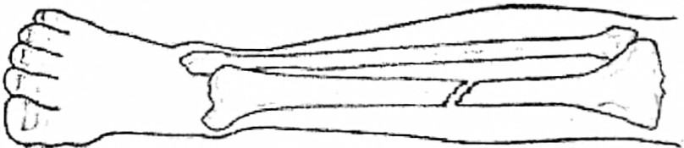

8. Identify the type of fracture shown above.

…………………………………………………………………………………………………

9. Give the first aid for the above accident.

…………………………………………………………………………………………………

10. Name the element of weather that may make people sweat.

…………………………………………………………………………………………………

11. Give the difference between a burn and a scald.

…………………………………………………………………………………………………

12. Why do some people rear cattle in your community?

…………………………………………………………………………………………………

13. Give the use of a beam balance to a shop attendant.

…………………………………………………………………………………………………

14. Why does a mother hen cover its chicks with wings?

…………………………………………………………………………………………………

15. Mention any **one** solute commonly used in our homes.

…………………………………………………………………………………………………

16. State **one** reason why birds are grouped under living things.

…………………………………………………………………………………………………

17. Give the importance of water during seed germination .

…………………………………………………………………………………………………

18. Why should crude oil be mined sparingly?

…………………………………………………………………………………………………

19. What happens to the diaphragm during breathing in?

…………………………………………………………………………………………………

20. Give any **one** use of kidneys in our bodies.

…………………………………………………………………………………………………

21. How does heat travel through metals?

…………………………………………………………………………………………………

22. Name any **one** tick borne disease in cattle.

…………………………………………………………………………………………………

23. Why is a ball point pen unable to sink in water?

…………………………………………………………………………………………………

24. Identify any **one** main part of a lever.

…………………………………………………………………………………………………

25. State any **one** way the effect of severe diarrhoea can be controlled in children.

…………………………………………………………………………………………………

26. Why should water be put in a clean container after boiling?

…………………………………………………………………………………………………

27. State **one** way friction is useful to people.

…………………………………………………………………………………………………

28. **The diagram below shows reflection on a smooth shiny surface.**

Complete the diagram by showing the reflected ray.

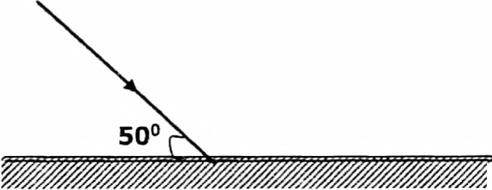

Smooth shiny surface

29. Which disease in humans is spread through bites of tsetse flies?

…………………………………………………………………………………………………

30. Name **one** management practice used to control vices in poultry.

…………………………………………………………………………………………………

31. Give any **one** device that uses magnets to function.

…………………………………………………………………………………………………

32. State any **one** way you can keep rabbits healthy.

…………………………………………………………………………………………………

33. Name the document used to monitor the growth rate of a baby.

…………………………………………………………………………………………………

The diagram below shows a traditional farm structure. Study and answer questions 34and **35.**

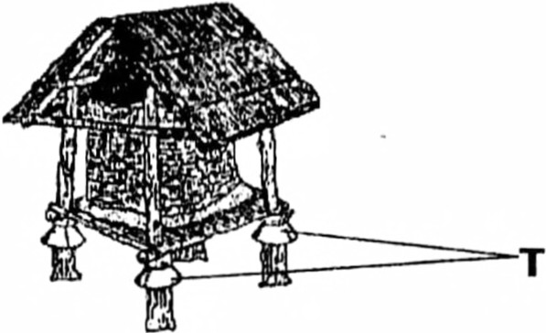

34. Give the use of the above structure to people.

…………………………………………………………………………………………………

35. Identify the part marked **T.**

…………………………………………………………………………………………………

36. Give **one** reason why physical exercise are important to people.

…………………………………………………………………………………………………

37. Outline any **one** method used to control tuberclosis in your community.

…………………………………………………………………………………………………

38. State any **one** characteristic of images formed in a plane mirror.

…………………………………………………………………………………………………

39. Which type of soil is used to make pots?

…………………………………………………………………………………………………

40. Give the use of planting short grass in a home compound.

…………………………………………………………………………………………………

**SECTION B: 60 Marks.**

41. (a) In **one** sentence, define the deficiency diseases.

…………………………………………………………………………………………………

(b) Name any **two** deficiency diseases.

i)………………………………………………………………………………………………

ii)………………………………………………………………………………………………

( c) Outline **one** way of controlling deficiency diseases at home.

…………………………………………………………………………………………………

42. (a) Besides fighting, name any other **two** anti-social behaviours in a classroom.

i)………………………………………………………………………………………………

ii)………………………………………………………………………………………………

. (b) Outline any **two** ways school administrators use to control anti-social behavours in your school.

i)………………………………………………………………………………………………

ii)………………………………………………………………………………………………

43. (a) In **one** sentence, define the term crop rotation.

……………………………………………………………………………………………………………………………………………………………………………………………………

(b) Why are legumes included in a crop rotation cycle?

…………………………………………………………………………………………………

c) Outline any two advantages of practicing crop rotation.

…………………………………………………………………………………………………

44. (a) Name any **one** type of honey bee.

…………………………………………………………………………………………………

(b) Give **one** raw material bees use to make honey.

………………………………………………………………………………………………

( c) How do plant benefit from bees?

………………………………………………………………………………………………

(d) State **one** way of caring for bees.

…………………………………………………………………………………………………

45. **The diagram below shows production of a gas fuel. Study and**

**answer question 45.**

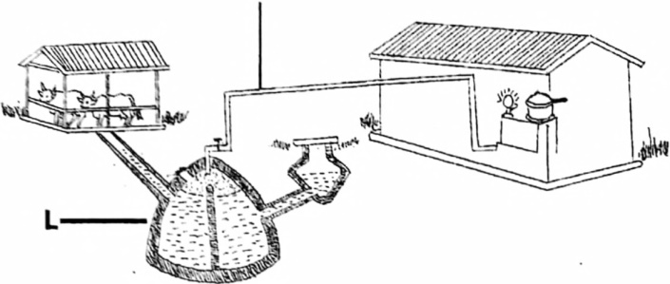**s**

(a) Name the equipment marked **L.**

…………………………………………………………………………………………………

(b) Mention any two materials used in container marked L.

i)……………………………………………………………………………………………….

ii)………………………………………………………………………………………………

c) Give any **one** use of the gas fuel found at **S.**

…………………………………………………………………………………………………

46. (a) Besides biological changes, name one other type of change in our environment.

…………………………………………………………………………………………………

(b) Name any **one** example of biological change in animal and plants.

(i) animals……………………………………………………………………………………

(ii) plants………………………………………………………………………………………

(c) State **one** characteristic of biological changes.

…………………………………………………………………………………………………

47. Match the items in list **A** to those in list **B** correctly.

**List A List 8**

snail bites the enemy with fangs

millipede pulls back into the shell

goat by curling

snake by goring

snail ………………………………………………………………………………………..

millipede……………………………………………………………………………………..

goat…………………………………………………………………………………………

snake………………………………………………………………………………………..

48. **The diagram below shows a garden equipment commonly used in rural areas. Study and answers question 48.**

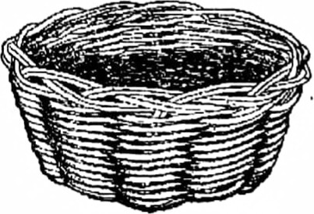

1. Identify the garden equipment shown above.

…………………………………………………………………………………………………

1. Name **one** material used to make the above equipment.

…………………………………………………………………………………………………

1. Give the use of the above equipment to family members.

…………………………………………………………………………………………………

1. How can you care for the above equipment?

…………………………………………………………………………………………………

49. **The diagram below shows the human ear. Study and answer question 49.**

**K**

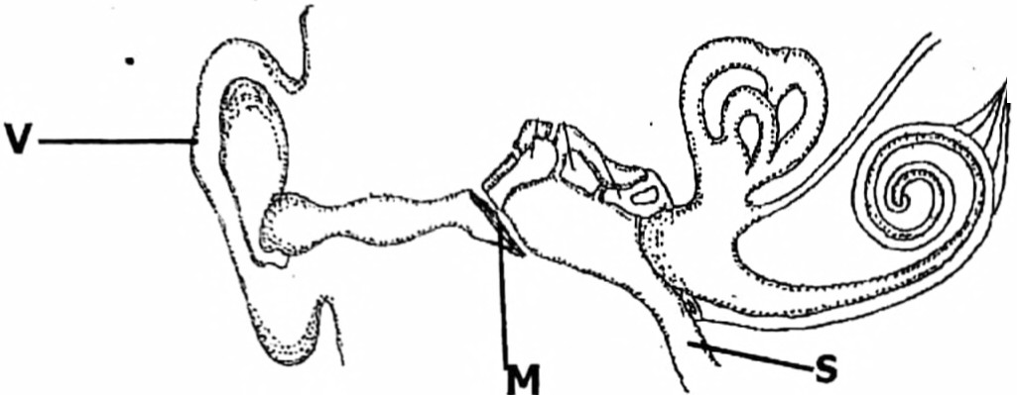

(a) Identify parts labelled Sand **K.**

(i) **S**…………………………………………………………………………………………

(ii) **K**…………………………………………………………………………………………

(b) _Which part collects sound waves?

…………………………………………………………………………………………………

(c) Besides hearing, give **one** other use of the above organ to people.

…………………………………………………………………………………………………

50. (a) Outline any **two** uses of blood in the human body.

i)……………………………………………………………………………………………….

ii)………………………………………………………………………………………………

(b)Give any **two** ways of increasing the volume of blood in a person who is anaemic.

i)……………………………………………………………………………………………….

ii)………………………………………………………………………………………………

51. **The picture below shows a restaurant near a public latrine. Study and answer question 51.**

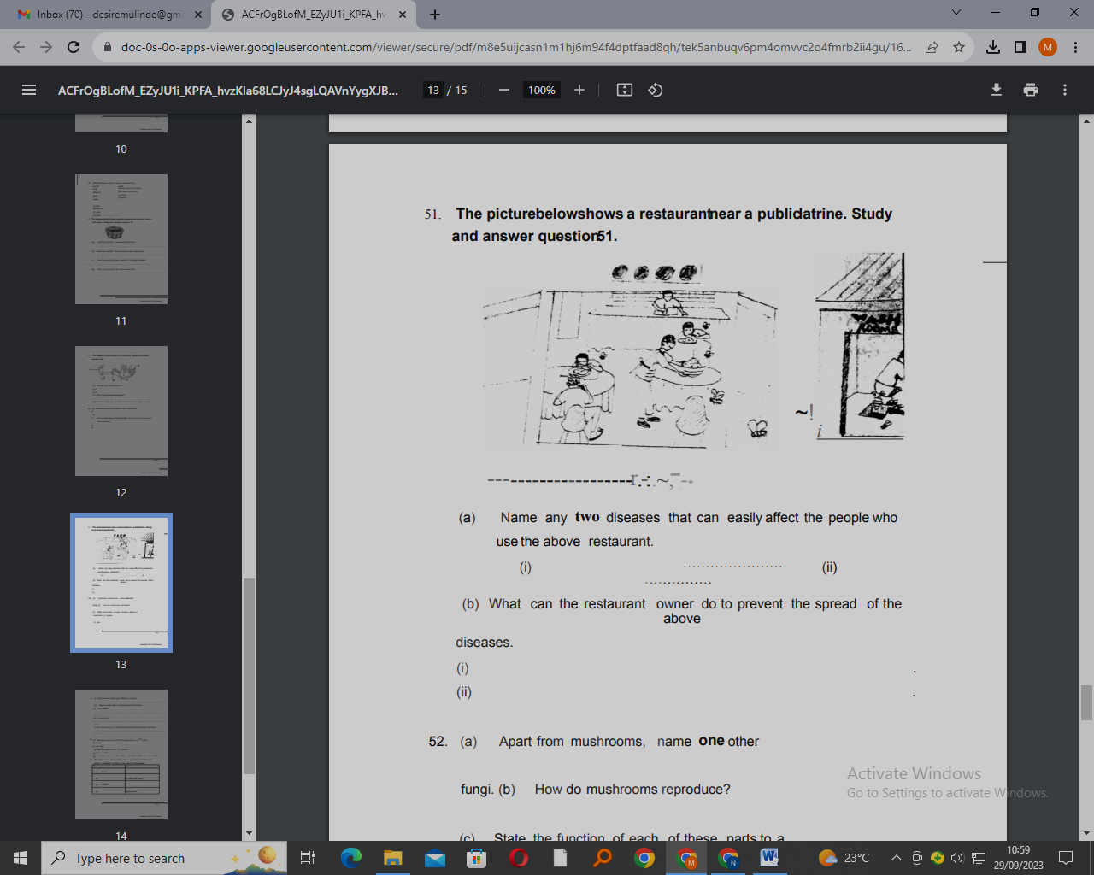

(a) Name any **two** diseases that can easily affect the people who use the above restaurant.

i)……………………………………………………………………………………………….

ii)………………………………………………………………………………………………

(b) What can the restaurant owner do to prevent the spread of the above diseases?

i)……………………………………………………………………………………………….

ii)………………………………………………………………………………………………

52. (a) Apart from mushrooms, name **one** other fungi.

………………………………………………………………………………………………………

(b) How do mushrooms reproduce?

…………………………………………………………………………………………………

(c) State the function of each of these parts to a mushroom.

i) hyphae………………………………………………………………………………….......

ii) gills………………………………………………………………………………………….

53.(a) Name any **one** body organ affected by alcohol.

…………………………………………………………………………………………………

(b) State any **one** effect of alcoholism to the following.

(i) an individual

…………………………………………………………………………………………………

(ii) a community

…………………………………………………………………………………………………

(c) Give any one-way P.7 children can protect themselves from alcoholism.

…………………………………………………………………………………………………

54. (a) State **one** use of each of the following parts on a VIP latrine.

i) screen pipe…………………………………………………………………………………

ii) vent…………………………………………………………………………………………

b) How do people care for VIP latrines?

i)………………………………………………………………………………………………

ii)………………………………………………………………………………………………

55. **The table below shows items used in promoting sanitation in a school. Complete by filling in the missing information.**

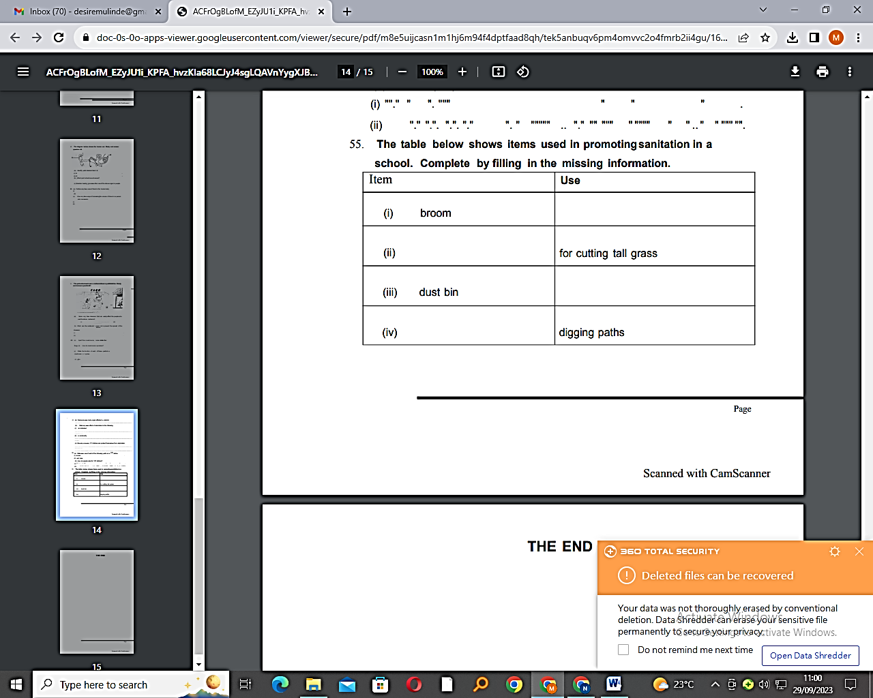

**END**